Week Three-Day-One -Assignment
Assignment-1
Generated Playwright-Typescript code for Salesforce Login using Vibe coding:
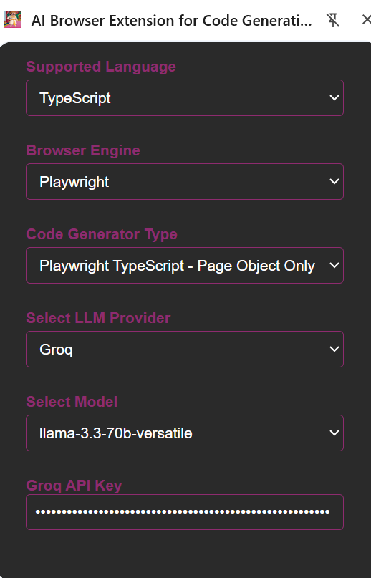
import { test, expect, Page } from '@playwright/test';

// Fixture for page object
test.beforeEach(async ({ page }) => {
await page.goto('https://login.salesforce.com/?locale=in');
});

test.describe('Login Tests', () => {
test('should login successfully with valid credentials', async ({ page }) => {
try {
await page.fill('input[name="username"]', 'suresh.kumar@salesforce.com');
await page.fill('input[name="pw"]', 'Suresh@123');
await page.click('button:has-text("Log In")');
await expect(page).toHaveURL(/.*dashboard/);
} catch (error) {
console.error('Error logging in with valid credentials:', error);
}
});

test('should show error with invalid credentials', async ({ page }) => {
try {
await page.fill('input[name="username"]', 'invaliduser');
await page.fill('input[name="pw"]', 'wrongpassword');
await page.click('button:has-text("Log In")');
await expect(page.locator('.error-message')).toBeVisible();
} catch (error) {
console.error('Error logging in with invalid credentials:', error);
}
});

test('should show error with empty credentials', async ({ page }) => {
try {
await page.click('button:has-text("Log In")');
await expect(page.locator('.error-message')).toBeVisible();
} catch (error) {
console.error('Error logging in with empty credentials:', error);
}
});

test('should fill username and password fields', async ({ page }) => {
try {
await page.fill('input[name="username"]', 'ramesh.nagar@salesforce.com');
await page.fill('input[name="pw"]', 'Ramesh@123');
await expect(page.locator('input[name="username"]')).toHaveValue('ramesh.nagar@salesforce.com');
await expect(page.locator('input[name="pw"]')).toHaveValue('Ramesh@123');
} catch (error) {
console.error('Error filling username and password fields:', error);
}
});

test('should login with username and password from Bangalore', async ({ page }) => {
try {
await page.fill('input[name="username"]', 'bangalore.user@salesforce.com');
await page.fill('input[name="pw"]', 'Bangalore@123');
await page.click('button:has-text("Log In")');
await expect(page).toHaveURL(/.*dashboard/);
} catch (error) {
console.error('Error logging in with username and password from Bangalore:', error);
}
});

test('should login with username and password from Chennai', async ({ page }) => {
try {
await page.fill('input[name="username"]', 'chennai.user@salesforce.com');
await page.fill('input[name="pw"]', 'Chennai@123');
await page.click('button:has-text("Log In")');
await expect(page).toHaveURL(/.*dashboard/);
} catch (error) {
console.error('Error logging in with username and password from Chennai:', error);
}
});

test('should login with username and password from Hyderabad', async ({ page }) => {
try {
await page.fill('input[name="username"]', 'hyderabad.user@salesforce.com');
await page.fill('input[name="pw"]', 'Hyderabad@123');
await page.click('button:has-text("Log In")');
await expect(page).toHaveURL(/.*dashboard/);
} catch (error) {
console.error('Error logging in with username and password from Hyderabad:', error);
}
});
});
Assignment 2: used the Bug magnet extension to fill the create lead form
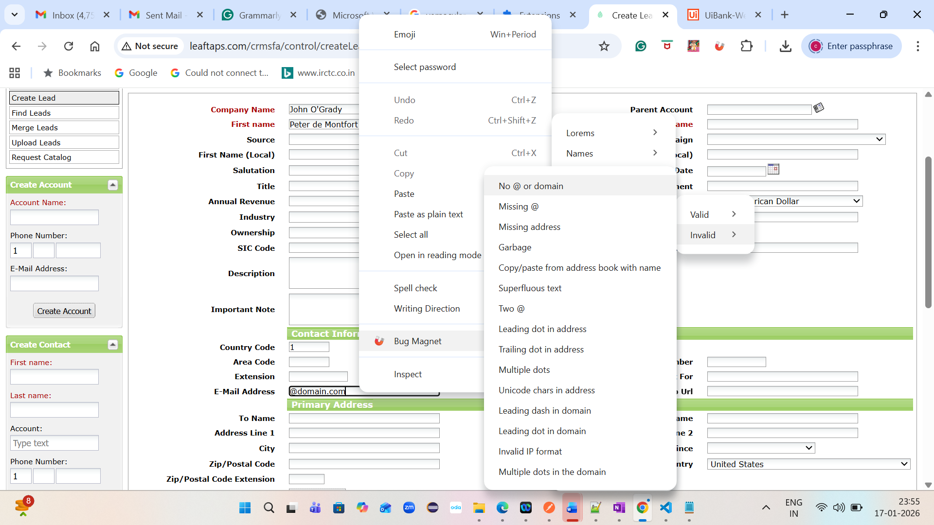
Assignment 3:
Grammarly
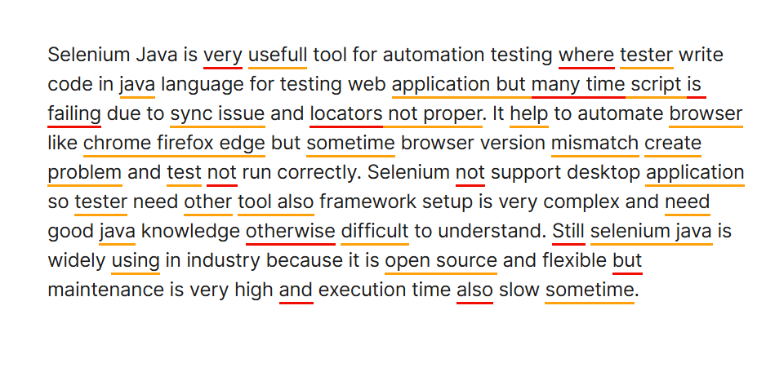
Corrected one
